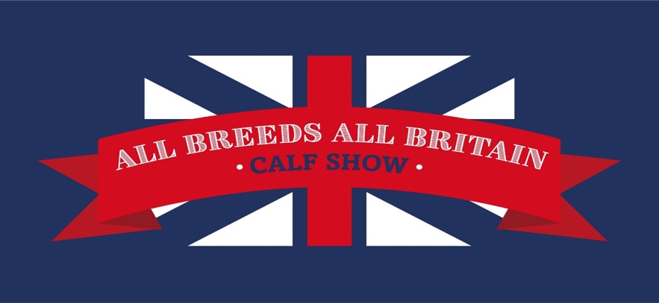

ALL BREEDS ALL BRITAIN CALF SHOW 2025

Friday 19th – Sunday 21st September

Staffordshire County Showground, ST18 0BD

**COLOURED BREEDS ENTRY FORM**

***ENTRIES TO BE RECEIVED BY BREED SOCIETIES BY MONDAY 1 SEPTEMBER***

***All Entries to be submitted on official entry forms (one per breed), please indicate if you have entered more than one coloured breed if you wish for them to be stalled together***

Please forward entry forms and fees to the relevant Breed Society, headed All Breeds All Britain Calf Show 2025:

AYRSHIRE: Ayrshire Cattle Society, Holme House, Dale, Ainstable, Carlisle, Cumbria CA4 9RH

[Registrations@ayrshirescs.org](mailto:registrations@ayrshirescs.org)

BRITISH FRIESIAN: N. Lewis, Scope House, Hortonwood 33, Telford, Shropshire TF1 7EX

[naomilewis@holstein-uk.org](mailto:naomilewis@holstein-uk.org)

BROWN SWISS: Sarah LiddleRose Cottage, Little Fencote, Northallerton, North Yorkshire DL7 0RR

[office@brownswiss.org](mailto:office@brownswiss.org)

DAIRY SHORTHORN: Pedigree Livestock Services, Holme House, Dale, Ainstable, Carlisle, Cumbria CA4 9RH

[breedsecretary@shorthorn.co.uk](mailto:breedsecretary@shorthorn.co.uk)

GUERNSEY: Helen Cox, White Lodge, Rickeston, Milford Haven, SA73 3TJ

[office@guernseycattle.com](mailto:%20office@guernseycattle.com)

JERSEY: Jersey Cattle Society, Holme House, Dale, Ainstable, Carlisle, Cumbria CA4 9RH

office@thejcs.uk

# SHOWMANSHIP CLASSES – FOC ENTRY

**CLASS NUMBER**

Name

DOB

Breed

**CLASS NUMBER**

Name

DOB

Breed

**CLASS NUMBER**

Name

DOB

Breed

**CLASS NUMBER**

Name

DOB

Breed

**CLASS NUMBER**

Name

DOB

Breed

**CLASS NUMBER**

Name

DOB

Breed

# CALF CLASSES - £30 PER ENTRY (all Breeds)

**Breed Exhibitor .**

**More than one breed entered Yes/No Breeds to be stalled together Yes/No**

**E-Mail Mobile number .**

**Contact at show .**

**CLASS NUMBER**

Name Ear tag no

Sire Dam

DOB Exhibitor bred YES/NO

**CLASS NUMBER**

Name Ear tag no

Sire Dam

DOB Exhibitor bred YES/NO

**CLASS NUMBER**

Name Ear tag no

Sire Dam

DOB Exhibitor bred YES/NO

**CLASS NUMBER**

Name Ear tag no

Sire Dam

DOB Exhibitor bred YES/NO

**CLASS NUMBER**

Name Ear tag no

Sire Dam

DOB Exhibitor bred YES/NO

**CLASS NUMBER**

Name Ear tag no

Sire Dam

DOB Exhibitor bred YES/NO

**CLASS NUMBER**

Name Ear tag no

Sire Dam

DOB Exhibitor bred YES/NO

**CLASS NUMBER**

Name Ear tag no

Sire Dam

DOB Exhibitor bred YES/NO

**CLASS NUMBER**

Name Ear tag no

Sire Dam

DOB Exhibitor bred YES/NO

**CLASS NUMBER**

Name Ear tag no

Sire Dam

DOB Exhibitor bred YES/NO

I hereby certify that the contents herein is correct to the best of my knowledge and belief, and I hereby agree to conform to and abide by the showing rules and regulations of the relevant Society, which have been read prior to me signing this form, together with the show rules as stated in the schedule.

PREFIX:

BREED SOCIETY:

NAME:

SIGNATURE:

DATE: