2017 ALL BREEDS ALL BRITAIN CALF SHOW

Friday 13th – Sunday 15th October

Three Counties Showground, Malvern

COLOURED BREEDS SCHEDULE

ENTRIES RECIEVED AFTER FRIDAY 29TH SEPTEMBER 2017 WILL NOT BE CONSIDERED

SHOW DIRECTOR
Mr. Edward Griffiths

SHOW MANAGERS
Mrs. Miriam Bagley
Mrs. Hannah Williams

COLOURED BREEDS COORDINATORS
Mr. Duncan Hunter
Ms. Nicola Dean

COLOURED BREED JUDGES’ STEWARD
Ms. Kirsten Bevis

TIMETABLE

FRIDAY 13th OCTOBER

12:00 – 22:00 Calves may arrive on site. Please note that all calves MUST arrive no later than 22:00. Those requiring entry prior to 12:00 due to transport must apply beforehand.

19:00 – 19:30 Holstein showmanship demonstration

19:30 – 20:00 Coloured breeds showmanship demonstration

SATURDAY 14th OCTOBER

10:00 Holstein & coloured breeds showmanship classes commence
20:00 – 00.00 Young Breeders Celebration

SUNDAY 15th OCTOBER

08.30 Coloured breed calf classes commence
10:00 Holstein calf classes commence followed by coloured breeds & Holstein championships
14:30 Champions from all breeds will parade at the conclusion of the breed championships
15:00 Presentations
16:00 Calves may depart

VENUE

Directions
Three Counties Showground, Malvern, Worcestershire, WR13 6NW

The Showground is located approximately 8 miles from the M5 & M50 motorways. Follow brown signs from all main routes to Blue Gate off the A449.

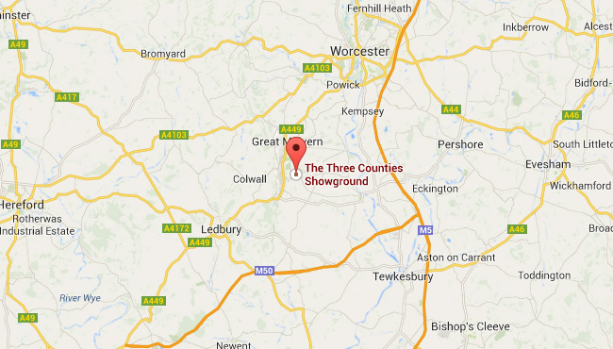

Showground
Please enter through Blue Gate and drop off at Wye Hall as per instruction from the Show Stewards. All livestock vehicles must be washed out after unloading at the lorry wash. Please depart via Brown Gate or park at Westgate car park.

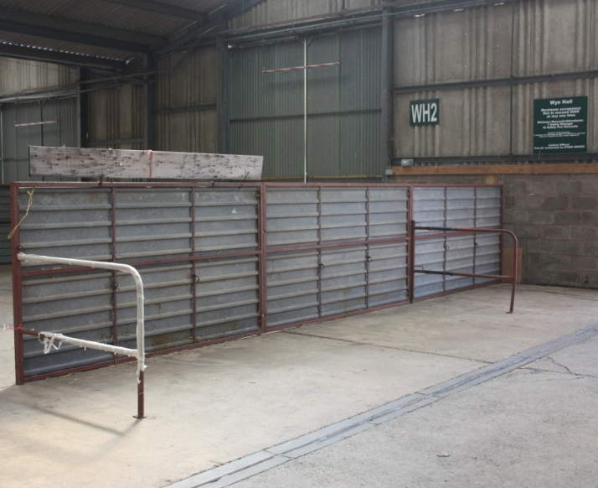
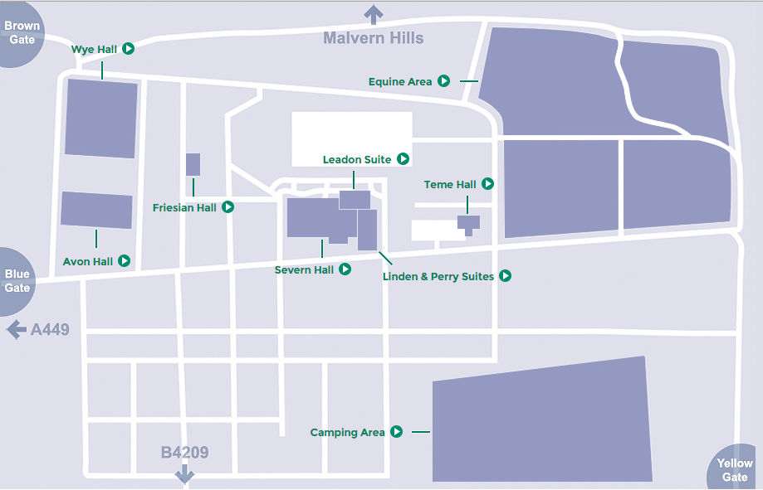

Wye Hall
Cattle lines, collecting ring & clipping area

Avon Hall
Holstein ring & coloured breeds ring

Friesian Hall
Littlestar interviews & Coordinators Meeting

Stockman’s Cafe
Young Breeders Celebration

SHOWMANSHIP CLASSES

Judge: Sam Wake
Stewards: Duncan Hunter, Kirsten Bevis & Ben Etteridge

Class 1 Junior Aged 12 years & under on 1st January 2017
Class 3 Intermediate Aged between 13 & 15 years on 1st January 2017
Class 5 Senior Aged between 16 & 20 years on 1st January 2017
Class 7 Mature Aged between 21 & 26 years on 1st January 2017

GRAHMAR TROPHY: Champion Jersey Showman

WRIGHT MANLEY TROPHY: Champion Ayrshire Showman

FRANK R MARSHALL TROPHY: Champion Shorthorn Showman

THE HILTON BROOKS PERPETUAL CHALLENGE CUP: Champion Guernsey Showman

THE BRITISH FRIESIAN CHAMPION HANDLER TROPHY: Champion British Friesian Showman

BROWN SWISS TROPHY: Champion Brown Swiss Showman

Calf Classes

JERSEY CALF CLASSES - ENTRIES £10 PER STALL
Judge: Richard Saxby
Steward(s): Mark Logan & Barry Daw

Class 16 Born on or after 1st March 2017
Class 22 Born between 1st December 2016 & 28th February 2017
Class 28 Born between 1st September & 30th November 2016
Class 34 Born between 1st May & 31st August 2016
Class 40 Born between 1st January & 30th April 2016

Rosettes will be presented 1st - 6th
BLUEGRASS TROPHY: Champion Jersey Calf

AYRSHIRE CALF CLASSES – ENTRIES £10 PER STALL
Judge: David Christophers
Steward(s): Duncan Hunter & Elaine Beresford

Class 17 Born on or after 1st March 2017
Class 23 Born between 1st December 2016 & 28th February 2017
Class 29 Born between 1st September & 30th November 2016
Class 35 Born between 1st May & 31st August 2016
Class 41 Born between 1st January & 30th April 2016
Rosettes will be presented 1st - 6th
WHITEFORD FAMILY TROPHY: Champion Ayrshire Calf

DAIRY SHORTHORN CALF CLASSES – ENTRIES £10 PER STALL
Judge: Paul Harrison
Steward(s): Mary Collins & Gwyndaff James

Class 18 Born on or after 1st March 2017
Class 24 Born between 1st December 2016 & 28th February 2017
Class 30 Born between 1st September & 30th November 2016
Class 36 Born between 1st May & 31st August 2016
Class 42 Born between 1st January & 30th April 2016

Rosettes will be presented to 1st – 6th
THE CHURCHROYD TROPHY: Champion Dairy Shorthorn Calf

GUERNSEY CALF CLASSES - ENTRIES £10 PER STALL
Judge: Iwan Thomas
Steward(s): Laura Barnes & Caroline Huins

Class 19 Born on or after 1st March 2017
Class 25 Born between 1st December 2016 & 28th February 2017
Class 31 Born between 1st September & 30th November 2016
Class 37 Born between 1st May & 31st August 2016
Class 43 Born between 1st January & 30th April 2016
Rosettes will be presented 1st – 6th
SNOWHILL CHALLENGE TROPHY: Champion Guernsey Calf

BROWN SWISS CALF CLASSES – ENTRIES £10 PER STALL

Judge: Hefin Wilson
Steward(s): Richard Johnson

Class 20 Born on or after 1st March 2017
Class 26 Born between 1st December 2016 & 28th February 2017
Class 32 Born between 1st September & 30th November 2016
Class 38 Born between 1st May & 31st August 2016
Class 44 Born between 1st January & 30th April 2016

Rosettes will be presented 1st - 6th
BROWN SWISS TROPHY: Champion Brown Swiss Calf

BRITISH FRIESIAN CALF CLASSES
Judge: Jane Arrell
Steward: Andrew Spicer

Class 21 Born on or after 1st March 2017
Class 27 Born between 1st December 2016 & 28th February 2017
Class 33 Born between 1st September & 30th November 2016
Class 39 Born between 1st May & 31st August 2016
Class 45 Born between 1st January & 30th April 2016

Rosettes will be presented to 1st - 6th
THE JACKSON TROPHY: Champion British Friesian Calf

IMPORTANT INFORMATION

STRAW & SHAVINGS

One bale of straw will be provided free of charge for each stall booked. Shavings & additional straw can be brought to the event but will not be available to purchase.

ARRIVAL & DEPARTURES

Registration certificates & passports MUST be brought to the event & will be checked by the Stewards. All animals attending the event MUST be accompanied by a pre-movement TB test certificate, regardless of the location of the holding they are travelling from. Paperwork MUST accompany the animals & be presented to the Stewards. Any calf unsatisfactorily identified at the event will not be allowed to participate. All calves must have both primary & secondary ear tags in accordance with DEFRA regulations. Any animal without double tags will not be allowed to enter the showground.

All calves MUST arrive on site by 22:00 on Friday. Late arrivals will not be permitted.

Departure must not be earlier than 16:00 on Sunday, directly after the final presentations. NO EARLY DEPARTURES WILL BE PERMITTED; please ensure all haulers are aware of this.

LIABILITY

Holstein UK cannot accept any liability for loss or damage to property, persons or livestock. It is the responsibility of each individual to ensure that adequate insurance cover & security measures are taken. No lorries or cattle trailers are permitted to park in the cattle sheds due to fire regulations.

CLIPPING & PREPARATION

At the event, any clipping or preparation of calves MUST be done by a member under 30 years old or the calf owner.

ELECTRICAL/COOKING EQUIPMENT

Health and safety regulations do not allow the use of any electrical or cooking equipment in the cattle lines. Kettles may be used but not urns; they MUST be placed on a solid surface & cables MUST NOT create a trip hazard. This MUST be strictly adhered to. A communal kitchen area will be provided in Bays 1 & 4. We ask everybody to please make use of these communal areas.

All electrical equipment MUST be PAT tested & in line with IEE regulations, paragraph 7.6.2.

FAKING

Any faking that is seen to take place, either by competitors or persons assisting in the preparation of the calves, will lead to disqualification from the competition. Doping of calves at the final is NOT permitted & any person seen doing so, or suspected of doing so, will be disqualified. Any injection to an animal must be reported to the Stewards prior to administration. False hair in toplines is not permitted.

ACCOMMODATION

CARAVANS & CAMPING

There are facilities for caravans & tents on the showground including showering facilities. Please contact Miriam Bagley at miriambagley@holstein-uk.org to book a caravan/tent pitch on a first come first serve basis. Please note that there will be a £20 charge per night for tents & caravans & a £5 charge per night for electricity, payable on entry. Strictly no vehicles or caravans are allowed in the cattle sheds.

LOCAL HOTELS

The Abbey Hotel
Abbey Rd, Great Malvern, Worcestershire, WR14 3ET (3.2 miles from the Showground)

The Cottage in the Wood
Holywell Rd, Malvern Wells, Worcestershire, WR14 4LG (1.6 miles from the Showground)

The Foley Arms Hotel
14 Worcester Rd, Malvern, Worcestershire, WR14 4QS (3.3 miles from the Showground)

The Mount Pleasant Hotel
50 Belle Vue Terrace, Great Malvern, Worcestershire, WR14 4PZ (3.2 miles from the Showground)

The Premier Inn, Malvern
Townsend Way, Malvern, Worcestershire, WR14 1GD (4.1 miles from the Showground)

CATERING
Catering will be available on-site throughout the weekend.

RULES

- Each entrant must be a fully paid up member of the relevant Society.

- Only competitors may lead the calves in the showmanship and calf classes; no assistance will be allowed.

- In the calf classes, calves must be handled by anyone 26 years of age or under on 1st January 2017. For the last two classes of each breed, calves may be handled by anyone 30 years or under on 1st January 2016.

- Each breed will be shown under their own Society’s rules.

- A calf may NOT be shown in more than one handler class.

- All competitors are required to wear the relevant Society's showing uniform. Entry will be refused if competitors are not wearing the correct uniform.

- Show Officials have the right to refuse entry to any competitors who are late for their class.

- Once at the Show any clipping or preparation of calves must only be done by the owner or a member aged 30 years of age or under.

- No substitutes or late entries will be permitted.

- Animals will undergo clinical inspection by the attending veterinary surgeon before entering the housing area. All certification must be presented to the attending veterinary surgeon on unloading.

- The correct pedigree certificate & passport must accompany all animals.

- Any animal with active ringworm will not be allowed into the show. Ringworm is defined as active if there is no hair re-growth. A written statement from your veterinary surgeon stating that the animal is undergoing treatment is required in these circumstances. We strongly recommend the use of Ringvac under veterinary guidance before the show, due to the high risk of ringworm transmission.

- All animals attending the event MUST be accompanied by a pre-movement TB test certificate, regardless of the location of the holding they are travelling from. Paper work MUST accompany the animals & be presented to the Stewards.

- It is recommended that animals have certification of a negative BVD antigen screen.

- Clippers, hairdryers & kettles MUST be PAT tested & in line with IEE regulations, paragraph 7.6.2.

- No animal previously or currently owned or bred by the judge (as stated in the schedule) is permitted to be shown.

- Non-payment of veterinary costs at the Show could result in suspension from future shows; as such, payment must be made within 28 days of receipt of invoice.

CODE OF CONDUCT

- The Show Committee expects all competitors to behave in a responsible & appropriate way throughout the event. Inappropriate behavior will NOT be tolerated.

- The actions of individuals are accountable by their relevant breed Society. The Show Committee reserves the right to disqualify exhibitors or even ban any members if they bring the reputation of the Society into question.

- All competitors will be issued with wristbands to distinguish between under & over 18’s, with no alcohol being served to under 18’s. Wristbands for bar access & access to the Young Breeders Celebration will be handed out by the Stewards on arrival or may be collected from the Cattle Office. Proof of identification will be required without exception.

- No alcohol will be allowed in the cattle lines for the duration of the event; stewards reserve the right to confiscate any alcohol found.

- Any one person found causing damage to property, persons or livestock will be immediately banned from taking part in the event & will be financially liable for any damages.

- Anyone under 18 who is not accompanied by a parent/guardian will require a parental consent form, which MUST be signed by a parent/guardian & returned prior to the event.

- Anyone under 16 should, ideally, be accompanied by a parent/guardian at events where an overnight stay is required.

