ALL BREED ALL BRITAIN CALF SHOW 2015

COLOUR BREEDS

SCHEDULE & ENTRY FORM

Friday 16th – Sunday 18th October

Three Counties Showground, Malvern, Worcestershire

SHOW DIRECTOR
Mr Edward Griffiths

SHOW COORDINATORS
Mrs Lynette Steel
Miss Rebecca Kirk

COLOURED BREED CHIEF STEWARD
Mr Nick Dain

COLOURED BREED CO-ORDINATOR
Miss Nicola Dean

ENTRIES RECIEVED AFTER MONDAY 5th OCTOBER 2015 WILL NOT BE CONSIDERD

TIMETABLE

FRIDAY 16th OCTOBER

12:00 – 22:00 Calves may arrive on site. NB please note that all calves MUST arrive no later than 22:00hrs. Those requiring entry prior to 12:00hrs due to transport must apply beforehand.

19:00 Showmanship Demonstrations

SATURDAY 17th OCTOBER

10:00 Showmanship classes commence
12:00 All stand building to be completed
20:00 – 00.00 Young Breeders Celebration

SUNDAY 18th OCTOBER

09:00 Individual Breed Calf Classes commence followed by Individual Breed Championships
14:30 Champion from All Breeds will parade at the conclusion of the Breed Championships
15:00 Presentations
15:30 Calf departure

VENUE

Directions
Three Counties Showground, Malvern, Worcestershire, WR13 6NW. Located approximately 8 miles from the M5 and M50 motorways. Follow brown signs from all main routes to Blue Gate off the A449.
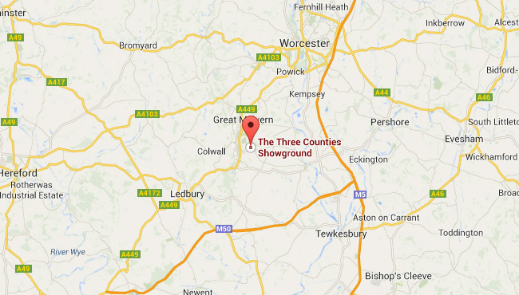

Showground
Please arrive through Blue Gate and drop off at Wye Hall as per instruction from the Show Stewards. All livestock vehicles must be washout out after unloading in the lorry wash. Depart at Brown Gate or park at Westgate car park.

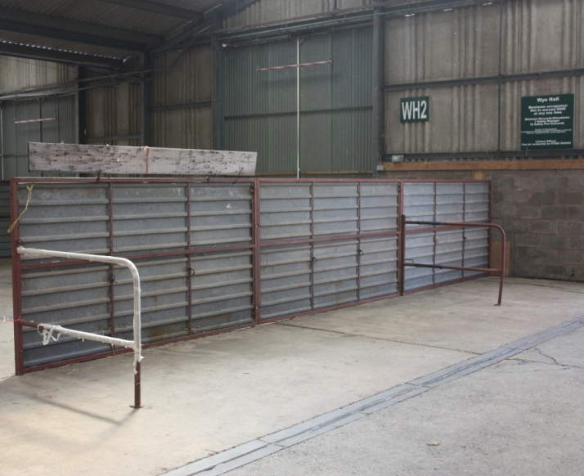
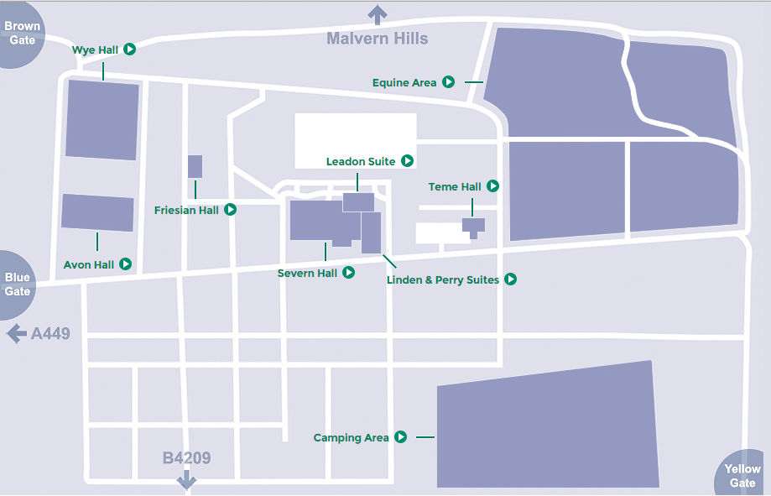

Wye Hall
Cattle lines, collecting ring and Calf Rearing Area. Plan to be confirmed.

Avon Hall
Main show ring and Colour Breeds ring. Plan to be confirmed.

Teme Hall
Young Breeders Celebration

Friesian Hall
The Holstein UK Annual General Meeting will take place within the Friesian Hall adjacent to Wye Hall on Saturday evening.

SHOWMANSHIP CLASSES

Judge: Miss Rebecca Jarvis
Steward: Mr Charles Reader

Class 1 Junior 12 years of age and under on 1st January 2015
Class 3 Intermediate Aged between 13 and 15 years of age on 1st January 2015
Class 5 Senior Aged between 16 and 20 years of age on 1st January 2015
Class 7 Mature Aged between 21 and 26 years of age on 1st January 2015

GRAHMAR TROPHY: Champion Jersey Showman

WRIGHT MANLEY TROPHY: Champion Ayrshire Showman

FRANK R MARSHALL TROPHY: Champion Shorthorn Showman

THE HILTON BROOKS PERPETUAL CHALLENGE CUP: Champion Guernsey Showman

THE BRITISH FRIESIAN CHAMPION HANDLER TROPHY: Champion British Friesian Showman

Calf Classes

AYRSHIRE CALF CLASSES
Judge: Mr Geraint Thomas
Steward: Mr Duncan Hunter

Class 16 Born on or after 1st March 2015
Class 22 Born between 1st December 2014 & 28th February 2015
Class 28 Born between 1st September & 30th November 2014
Class 34 Born between 1st May & 31st August 2014
Class 40 Born between 1st January & 30th April 2014
Rosettes (sponsored by Cattle Services (Ayr) Ltd) will be presented to all entries forward
WHITEFORD FAMILY TROPHY awarded to the Champion Ayrshire Calf

BRITISH FRIESIAN CALF CLASSES
Judge: Mr Owain Harris
Steward: Mr Andrew Spicer

Class 20 Born on or after 1st March 2015
Class 26 Born between 1st December 2014 & 28th February 2015
Class 32 Born between 1st September & 30th November 2014
Class 38 Born between 1st May & 31st August 2014
Class 44 Born between 1st January & 30th April 2014

Rosettes will be presented to all entries forward
THE JACKSON TROPHY awarded to the Champion British Friesian Calf

DAIRY SHORTHORN CALF CLASSES
Judge: Mr David Slade
Stewards: Mrs Mary Collins & Gwyndaff James

Class 17 Born on or after 1st March 2015
Class 23 Born between 1st December 2014 & 28th February 2015
Class 29 Born between 1st September & 30th November 2014
Class 35 Born between 1st May & 31st August 2014
Class 41 Born between 1st January & 30th April 2014

Rosettes will be presented to all entries forward
THE CHURCHROYD TROPHY awarded to the Champion Shorthorn Calf

GUERNSEY CALF CLASSES
Judge: Mr David Christophers
Steward: Ms Kirsten Bevis

Class 18 Born on or after 1st March 2015
Class 24 Born between 1st December 2014 & 28th February 2015
Class 30 Born between 1st September & 30th November 2014
Class 36 Born between 1st May & 31st August 2014
Class 42 Born between 1st January & 30th April 2014
Rosettes will be presented to all entries forward
SNOWHILL CHALLENGE TROPHY awarded to the Champion Guernsey Calf

JERSEY CALF CLASSES
Judge: Mr Frank Poskit
Steward: Ms Sarah Liddle

Class 15 Born on or after 1st March 2015
Class 21 Born between 1st December 2014 & 28th February 2015
Class 27 Born between 1st September & 30th November 2014
Class 33 Born between 1st May & 31st August 2014
Class 39 Born between 1st January & 30th April 2014

Rosettes will be presented to all entries forward
BLUEGRASS TROPHY awarded to the Champion Jersey Calf

BROWN SWISS CALF CLASSES

Judge: Mr Murray Cochrane
Steward: TBC

Class 19 Born on or after 1st March 2015
Class 25 Born between 1st December 2014 & 28th February 2015
Class 31 Born between 1st September & 30th November 2014
Class 37 Born between 1st May & 31st August 2014
Class 43 Born between 1st January & 30th April 2014

IMPORTANT INFORMATION

ENTRY FEES
Entries fees are £6.00 INCLUDING VAT per animal. Fees are required on entry and should be payable to the relevant breed society.

STRAW AND SHAVINGS
One bale of straw will be provided free of charge for each stall booked. Shavings and additional straw can be brought to the event but will not be available to purchase.

ARRIVAL AND DEPARTURES
Registration certificates and passports MUST be brought to the event and will be checked by the stewards.

All animals attending the event MUST be accompanied by a pre-movement TB test certificated regardless of the location of the holding they are travelling from. Paper work MUST accompany the animals and be presented to the Show Officials. Any calf unsatisfactorily identified at the event will not be allowed to participate. All calves must possess both primary and secondary ear tags due to DEFRA regulations. Any animal without double tags will not be allowed to enter the showground.

All calves MUST arrive on site by 22:00 on Friday. Late arrivals will not be permitted.

Departure not earlier than 15:30 on Sunday directly after the final presentations. No early departures will be permitted; please ensure all haulers are aware of this.

LIABILITY
Holstein UK cannot accept any liability for loss or damage to property, person or livestock. It is the responsibility of each individual to ensure that adequate insurance cover and security measures are taken. No lorries or cattle trailers are permitted to park in the cattle sheds due to fire regulations.

ELECTRICAL/COOKING EQUIPMENT
Health and safety regulations do not allow the use of any electrical or cooking equipment in the cattle lines. Kettles may be used but not urns, they MUST be placed on a solid surface and cables MUST not create a trip hazard. This will be strictly adhered to. A communal kitchen area will be provided in bay 1 and bay 4. We ask everybody to make use of these communal areas that have been provided.

All electrical equipment MUST be PAT tested and in line with IEE regulations, paragraph 7.6.2.

FAKING
Any faking that is seen to take place, either by the competitors or persons assisting in the preparation of the calf, will lead to disqualification from the competition. Doping of calves at the final is also NOT permitted and any person seen doing so, or suspected of doing so, will be disqualified. Any injection to an animal must be reported to the chief steward prior to administration. False hair in topline is not permitted.

ANIMAL HEALTH
Our Event Duty Vet recommends all animals to be isolated for 2 weeks on return from the show and monitored for signs of clinical disease in accordance with your Herd Health Plan. IBR marker live vaccine of animals before the show in accordance with the product data sheet is also recommended.

SUBSTITUTES
If a 1st place winner cannot attend the All Britain All Breed Calf Show, it can be substituted by the 2nd placed, etc. This ruling also applies to the showmanship classes. However, to ensure accuracy of the catalogue any alterations should be notified to Holstein UK as soon as possible.

CARAVANS & CAMPING
There are facilities for caravans and tents on the showground including showering facilities. Please contact Rebecca Kirk on rebeccakirk@holstein-uk.org to book a caravan/tent pitch on a first come first serve basis. Please note that there will be a £5.00 charge per day for caravans payable to the steward on entry. Strictly no vehicles or caravans in the cattle sheds.

LOCAL HOTELS

The Abbey Hotel
Abbey Rd, Great Malvern, Worcestershire WR14 3ET (3.2 miles from showground).

The Cottage in the Wood
Holywell Rd, Malvern Wells, WR14 4LG (1.6 miles from show ground).

For bookings contact 01684 588860.

The Foley Arms Hotel
14 Worcester Rd, Malvern, Worcestershire WR14 4QS (3.3 miles from showground).

For bookings contact 01684 580350

The Mount Pleasant Hotel
50 Belle Vue Terrace, Great Malvern, WR14 4PZ (3.2 miles from showground).

The Premier Inn, Malvern
Townsend Way, Malvern WR14 1GD. (4.1 miles from showground).

CATERING

The stockman’s canteen will be open from Friday 12:00 until Sunday 15:00 at normal meal times. Full meals are available for £6 - £8 and Baguettes and Sandwiches £3.50 – 5.50.

RULES

- Each entrant must be a fully paid up member of the Society.

- Only the competitors may lead the calves in the showmanship and calf classes, no assistance will be allowed.

- In the calf classes, calves may be handled by anyone 26 or under on 1st January 2015. For the last two classes of each breed, calves may be handled by anyone 30 or under on 1st January 2015.

- Each breed will be shown under their own Society rules.

- A calf MAY NOT be shown in more than one handler class.

- All competitors are required to wear the appropriate Society's showing uniform. Entry will be refused if competitors are not wearing the correct uniform.

- Show Officials have the right to refuse entry to any competitors who are late for their class.

- Once at the show any clipping or preparation of calves must only be done by the owner or a member aged 26 and under.

- No substitutes or late entries will be permitted.

- Animals will have a clinical inspection by the attending veterinary surgeon prior to entry to the housing. All certification must be presented to the attending veterinary surgeon on unloading.

- The correct Pedigree certificate and Passport must accompany all animals.

- Any animal with active ringworm will not be allowed into the show. Ringworm is defined as active if there is no hair re-growth. A written statement from your veterinary surgeon stating that the animal is under treatment is required in these circumstances. We strongly recommend the use of Ringvac under veterinary guidance before the show due to the high risk of ringworm transmission.

- All animals attending the event MUST be accompanied by a pre-movement TB test certificated regardless of the location of the holding they are travelling from. Paper work MUST accompany the animals and be presented to the Show Officials.

- It is recommended that animals have certification of a negative BVD Antigen screen.

- No commercial advertising will be permitted.

- Clippers, Hairdryers & Kettles MUST be PAT tested and in line with IEE regulations, paragraph 7.6.2.

- No animal previously or currently owned or bred by the judge as stated in the schedule will be allowed to be shown.

- Non-payment of veterinary costs at the show could result in suspension from future shows therefore we would appreciate payment on receipt of invoice with 28 days.

CODE OF CONDUCT

- The show committee expects all competitors to behave in a responsible and appropriate way throughout the event. Inappropriate behavior WILL NOT be tolerated.

- The actions of individuals are accountable by the whole club and the responsibility of the Club Coordinator. The show committee reserves the right to remove travel allowances, disqualify exhibitors or even ban any members if they bring the reputation of the Society into question.

- The show committee will not accept any liability for loss or damage to property, persons or livestock during competitions. It is the responsibility of each individual to ensure that adequate insurance cover and security measures are taken.

- All competitors will be required to wear their Society’s’ showing uniform.

- All competitors will be issued with wristbands to distinguish between under and over 18’s, with no alcohol will be served to under 18’s. Wristbands for bar access and access to the Young Breeders Celebration must be collected from the Registration Office. Proof of identification will be required without exceptions.

- No alcohol will be allowed in the cattle lines for the duration of the event, stewards reserve the right to confiscate any alcohol found.

- Any one person found causing damage to property or persons will be immediately banned from taking part in the event and will be made to pay for any damages.

- Anyone under 18 will require a Parental Consent form, which MUST be signed and returned before the event.

- Anyone under 16 should be accompanied by their parent/s at events where an overnight stay is required.

